2018 / Lisa Najavits, PhD / Treatment Innovations / Short version of basic handouts

PTSD
DSM-V definition: After a trauma (the experience, threat, or witnessing of physical harm, e.g., rape, hurricane), the person has each of the following key symptoms for over a month, and they result in decreased ability to function (e.g., work, social life): intrusion (e.g., flashbacks, nightmares); avoidance (not wanting to talk about it or remember); negative thoughts and mood; and arousal (e.g., insomnia, anger).
Simple PTSD results from a single event in adulthood (DSM-V symptoms); Complex PTSD is not a DSM term but may result from multiple traumas, typically in childhood (broad symptoms, including personality problems)
Rates: 10% for women, 5% for men (lifetime, U.S.). Up to 1/3 of people exposed to trauma develop PTSD.
Treatment: if untreated, PTSD can last for decades; if treated, people can recover. Evidence-based treatments include cognitive-behavioral-- coping skills training and exposure, i.e., processing the trauma story.

Substance Abuse
“The compulsion to use despite negative consequences” (e.g., legal, physical, social, psychological). Note that neither amount of use nor physical dependence define substance abuse.
DSM-V term is “substance-related and addictive disorder”, which can be mild, moderate, or severe.
Rates: 35% for men; 18% for women (lifetime, U.S.)
It is treatable disorder and a “no-fault” disorder (i.e., not a moral weakness)
Two ways to give it up: “cold turkey” (give up all substances forever; abstinence model) or “warm turkey” (harm reduction, in which any reduction in use is a positive step); moderation management, some people can use in a controlled fashion-- but only those not dependent on substances, and without co-occurring disorders).

The Link Between PTSD and Substance Abuse
About PTSD and substance abuse
Rates: Of clients in substance abuse treatment, 12%-34% have current PTSD. For women, rates are 33%-59%.
Gender: For women, typically a history of sexual or physical childhood trauma; for men, combat or crime
Drug choice: No one drug of choice, but PTSD is associated with severe drugs (cocaine, opioids); in 2/3 of cases the PTSD occurs first, then substance abuse.

Treatment issues
Other life problems are common: other Axis I disorders, personality disorders, interpersonal and medical problems, inpatient admissions, low compliance with aftercare, homelessness, domestic violence.
PTSD does not go away with abstinence from substances; and, PTSD symptoms are widely reported to become worse with initial abstinence.
Splits in treatment systems (mental health versus substance abuse).
Fragile treatment alliances and multiple crises are common.
Treatments helpful for either disorder alone may be problematic if someone has both disorders (e.g.,
emotionally intense exposure therapies, benzodiazepines), and should be evaluated carefully prior to use.

Recommended treatment strategies
Treat both disorders at the same time. Research supports this and clients prefer this.
Decide how to treat PTSD in context of active substance abuse. Options: (1) Focus on present only (coping skills, psychoeducation, educate about symptoms) [safest approach, widely recommended]. (2) Focus on past only (tell the trauma story) [high risk; works for some clients] (3) Focus on both present and past

Diversity Issues
Respect cultural differences and tailor treatment to be sensitive to historical prejudice. Recognize that terms such as trauma, PTSD, and addiction may be interpreted differently based on culture. Cultures also have protective factors (religion, kinship) that may prevent or heal trauma / addiction.

Seeking Safety
About Seeking Safety
A present-focused model to help clients (male and female) attain safety from PTSD and substance abuse.
Up to 25 topics that can be conducted in any order, doing as many as time allows:
• Interpersonal topics: Honesty, Asking for Help, Setting Boundaries in Relationships, Getting Others to Support Your Recovery, Healthy Relationships, Community Resources
• Cognitive topics: PTSD: Taking Back Your Power, Compassion, When Substances Control You, Creating Meaning, Discovery, Integrating the Split Self, Recovery Thinking
• Behavioral topics: Taking Good Care of Yourself, Commitment, Respecting Your Time, Coping with Triggers, Self-Nurturing, Red and Green Flags, Detaching from Emotional Pain (Grounding)
• Other topics: Introduction/Case Management, Safety, Life Choices, Termination
Designed for flexible use: can be conducted in group or individual format; for women, men, or mixed-gender; using all topics or fewer topics; in a variety of settings; and with a variety of providers (and peers).

Key principles of Seeking Safety
Safety as the goal for first-stage treatment (later stages are mourning and reconnection)
Integrated treatment (treat both disorders at the same time)
A focus on ideals to counteract the loss of ideals in both PTSD and substance abuse
Four content areas: cognitive, behavioral, interpersonal, case management
Attention to clinician processes: balance praise and accountability; notice your own emotional responses (fear, wish to control, joy in the work, disappointment); all-out effort; self-care

Additional features
- Trauma details not part of group therapy; in individual therapy, assess client’s safety and monitor carefully (particularly if has history of severe trauma, or if client is actively using substances)
- Identify meanings of substance use in context of PTSD (to remember, to forget, to numb, to feel, etc.)
- Optimistic: focus on strengths and future
- Help clients obtain more treatment and attend to daily life problems (housing, AIDS, jobs)
- Harm reduction model or abstinence
- 12-step groups encouraged, not required
- Empower clients whenever possible
- Make the treatment engaging: quotations, everyday language
- Emphasize core concepts (e.g., “You can get better”)

Evidence Base
Seeking Safety is an evidence-based model, with over 45 published research articles and consistently positive results. For all studies, go to www.seekingsafety.org, section Evidence. Studies include pilots, randomized controlled trials, multi-site trials.

Resources on Seeking Safety. All below are available from www.seekingsafety.org and/or from the order form at the end of this packet of handouts.
Implementation / research articles: all articles related to Seeking Safety can be freely downloaded.
Training: training calendar and information on setting up a training (section Training).
Consultation: on clinical implementation, research studies, evaluation projects.
Fidelity Scale: free download (section Assessment).
Book: Seeking Safety: A Treatment Manual for PTSD and Substance Abuse. Has the clinician guide and all client handouts. Also available in Spanish, French, German, Swedish, Dutch, Polish, Chinese, Vietnamese, Portuguese, Italian, and Greek. Upcoming: Japanese and Arabic will also become available.
DVD training series: four videos provide training on Seeking Safety. (1) Seeking Safety (two hour training video by Lisa Najavits); (2) Asking for Help (one-hour demonstration of a group session with real clients); (3) A Client’s Story (26 minute unscripted life story by a male trauma survivor) and Teaching Grounding (16 minute example of the grounding script from Seeking Safety with a male client); (4) Adherence Session (one hour session that can be rated with the Seeking Safety Adherence Scale).
Online learning
Teaching Guide to Introduce Seeking Safety to your agency
Engagement materials: card deck, poster, magnets, wallet card, key chain of the safe coping skills; in English, Spanish, French.

Contact Information
Contact: Treatment Innovations, 28 Westbourne Road, Newton Centre, MA 02478; 617-299-1610 [phone]; info@treatment-innovations.org [email]; www.seekingsafety.org or www. www.treatment-innovations.org [web]

We can add you to the Seeking Safety website to list that you conduct Seeking Safety. If desired email info@seekingsafety.org your basic information. Example: Boston, MA: Karen Smith, LICSW; group and individual Seeking Safety; private practice with sliding scale. 617-300-1234. Karensmith@netzero.com.

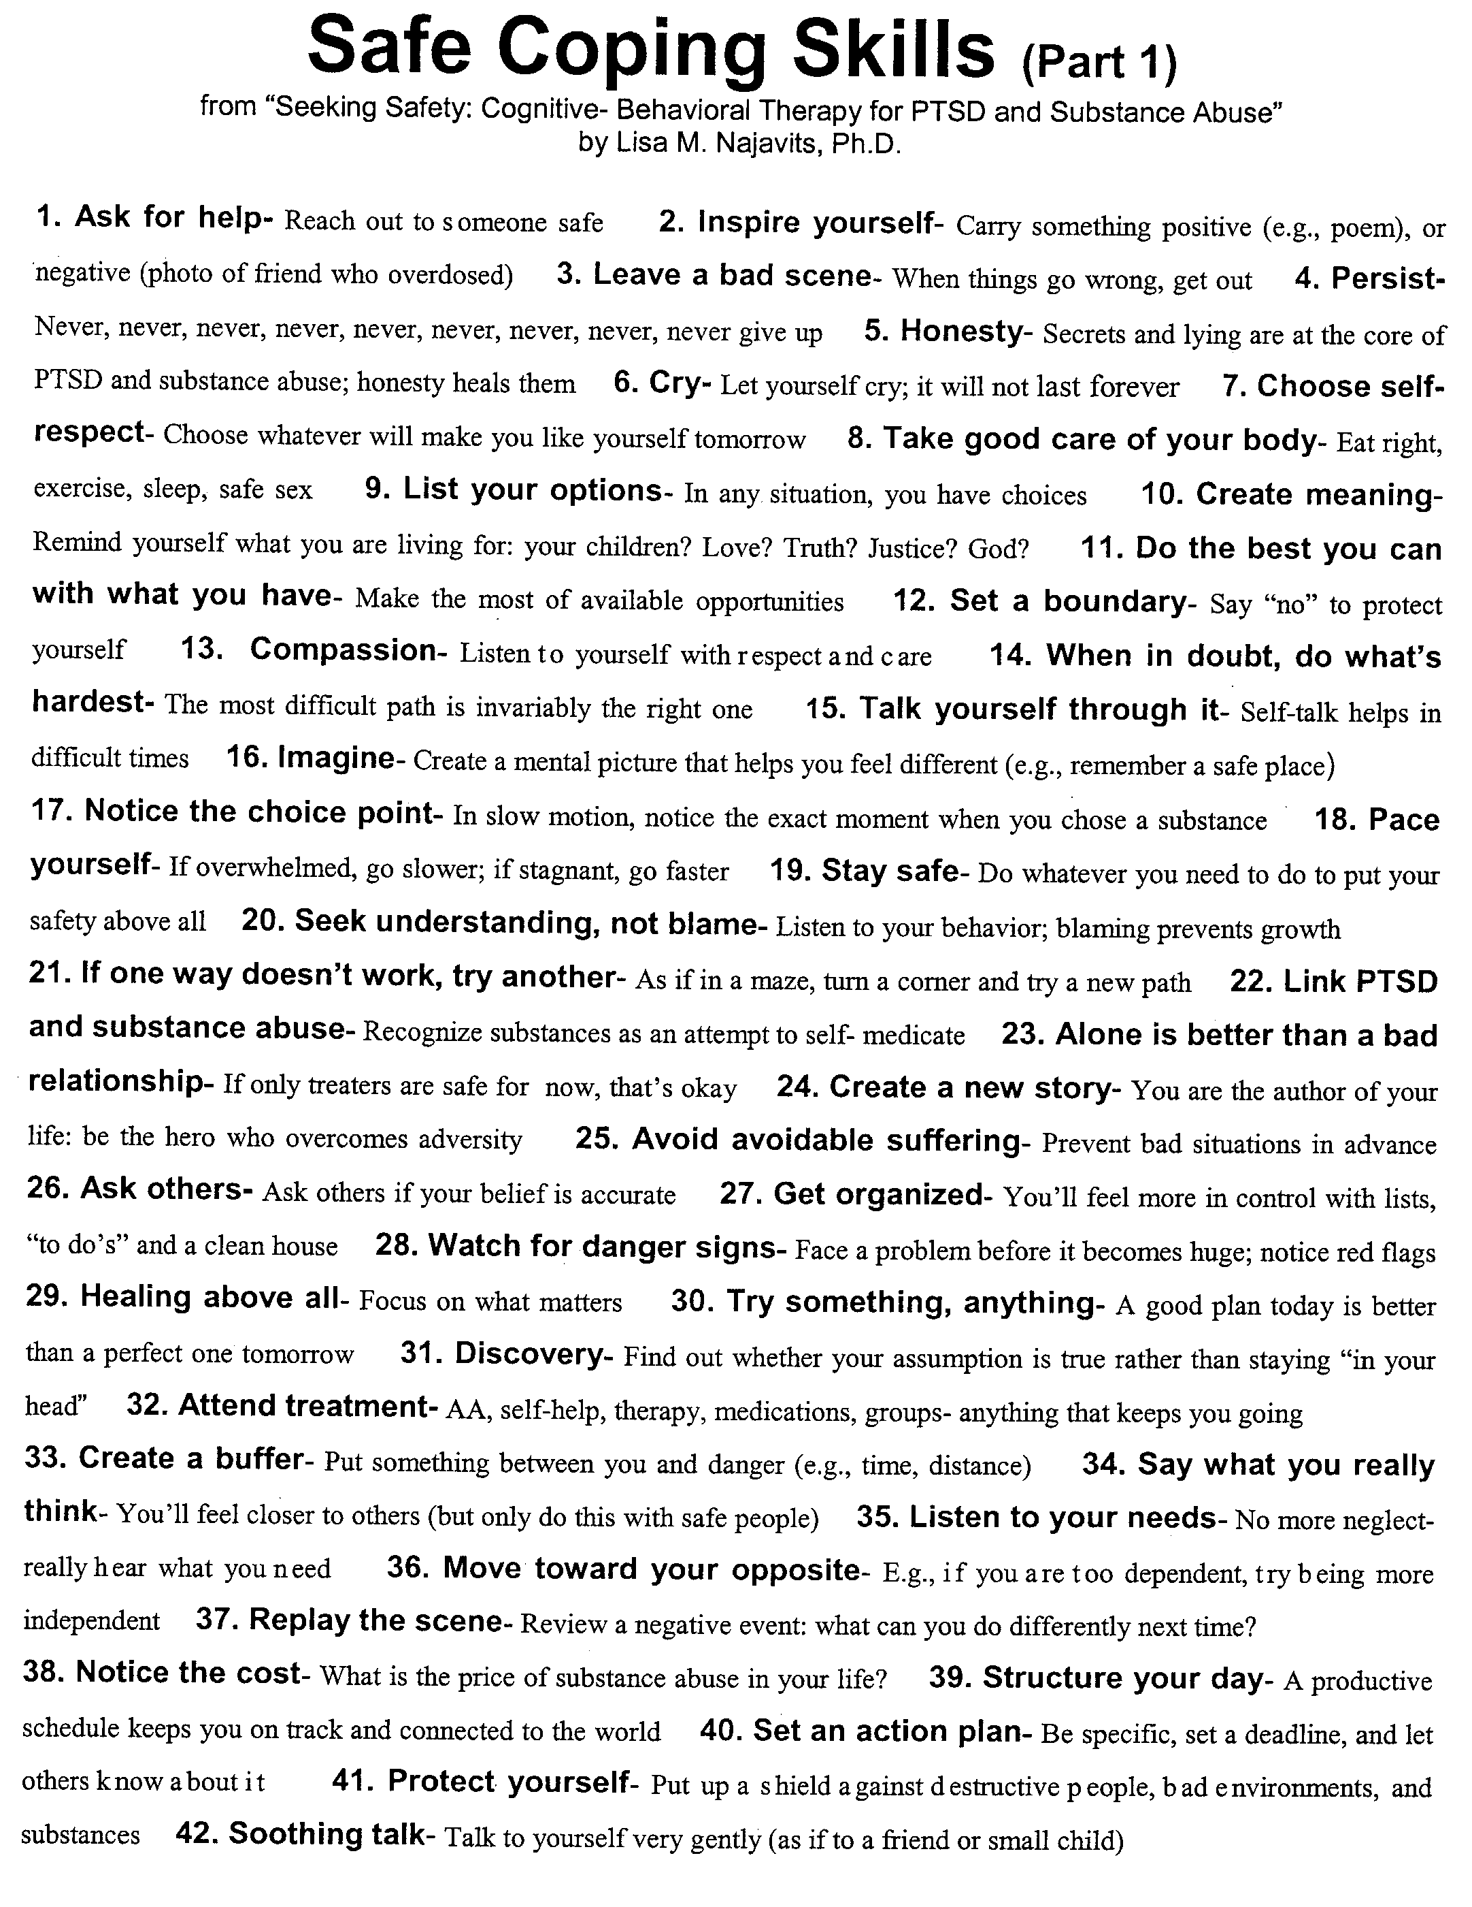
With appreciation to the Allies Program (Sacramento, CA) for formatting this Safe Coping List.
© Guilford Press, New York. From: Najavits, L.M. Seeking Safety: A Treatment Manual for PTSD and Substance Abuse (2002). Only for personal use (with clients); for any other use contact <info@seekingsafety.org> or <permissions@guilford.com>
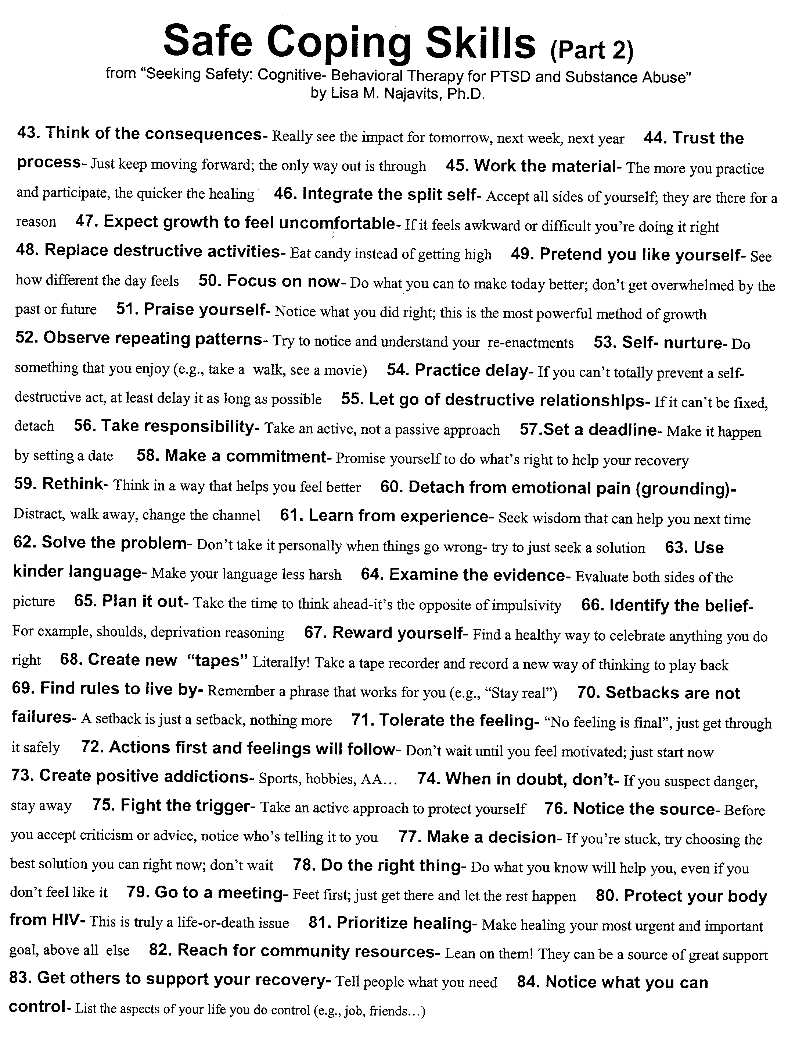
© Guilford Press, New York. From: Najavits, L.M. Seeking Safety: A Treatment Manual for PTSD and Substance Abuse (2002). Only for personal use (with clients); for any other use contact <infoseekingsafety.org> or <permissions@guilford.com>
Lisa Najavits, PhD
Detaching From Emotional Pain (Grounding)
WHAT IS GROUNDING?
Grounding is a set of simple strategies to detach from emotional pain (for example, drug cravings, self-harm impulses, anger, sadness). Distraction works by focusing outward on the external world-- rather than inward toward the self. You can also think of it as “distraction,” “centering,” “a safe place,” “looking outward,” or “healthy detachment.”
WHY DO GROUNDING?
When you are overwhelmed with emotional pain, you need a way to detach so that you can gain control over your feelings and stay safe. As long as you are grounding, you cannot possibly use substances or hurt yourself! Grounding “anchors” you to the present and to reality.
Many people with PTSD and substance abuse struggle with either feeling too much (overwhelming emotions and memories) or too little (numbing and dissociation). In grounding, you attain balance between the two-- conscious of reality and able to tolerate it.
Guidelines
- Grounding can be done any time, any place, anywhere and no one has to know.
- Use grounding when you are: faced with a trigger, having a flashback, dissociating, having a substance craving, or when your emotional pain goes above 6 (on a 0-10 scale). Grounding puts healthy distance between you and these negative feelings.
- Keep your eyes open, scan the room, and turn the light on to stay in touch with the present.
- Rate your mood before and after to test whether it worked. Before grounding, rate your level of emotional pain (0-10, where means “extreme pain”). Then re-rate it afterwards. Has it gone down?
- No talking about negative feelings or journal writing. You want to distract away from negative feelings, not get in touch with them.
- Stay neutral-- no judgments of “good” and “bad”. For example, “The walls are blue; I dislike blue because it reminds me of depression.” Simply say “The walls are blue” and move on.
- Focus on the present, not the past or future.
- Note that grounding is not the same as relaxation training. Grounding is much more active, focuses on distraction strategies, and is intended to help extreme negative feelings. It is believed to be more effective for PTSD than relaxation training.
WAYS TO GROUND
Mental Grounding
- Describe your environment in detail using all your senses. For example, “The walls are white, there are five pink chairs, there is a wooden bookshelf against the wall...” Describe objects, sounds, textures, colors, smells, shapes, numbers, and temperature. You can do this anywhere. For example, on the subway: “I’m on the subway. I’ll see the river soon. Those are the windows. This is the bench. The metal bar is silver. The subway map has four colors...”
- Play a “categories” game with yourself. Try to think of “types of dogs”, “jazz musicians”, “states that begin with ‘A’”, “cars”, “TV shows”, “writers”, “sports”, “songs”, “European cities.”
- Do an age progression. If you have regressed to a younger age (e.g., 8 years old), you can slowly work your way back up (e.g., “I’m now 9”; “I’m now 10”; “I’m now 11”…) until you are back to your current age.
- Describe an everyday activity in great detail. For example, describe a meal that you cook (e.g., “First I peel the potatoes and cut them into quarters, then I boil the water, I make an herb marinade of oregano, basil, garlic, and olive oil…”).
- Imagine. Use an image: Glide along on skates away from your pain; change the TV channel to get to a better show; think of a wall as a buffer between you and your pain.
- Say a safety statement. “My name is ____; I am safe right now. I am in the present, not the past. I am located in _____; the date is _____.”
- Read something, saying each word to yourself. Or read each letter backwards so that you focus on the letters and not on the meaning of words.
- Use humor. Think of something funny to jolt yourself out of your mood.
- Count to 10 or say the alphabet, very s..l..o..w..l..y.
- Repeat a favorite saying to yourself over and over (e.g., the Serenity Prayer).
Physical Grounding
- Run cool or warm water over your hands.
- Grab tightly onto your chair as hard as you can.
- Touch various objects around you: a pen, keys, your clothing, the table, the walls. Notice textures, colors, materials, weight, temperature. Compare objects you touch: Is one colder? Lighter?
- Dig your heels into the floor-- literally “grounding” them! Notice the tension centered in your heels as you do this. Remind yourself that you are connected to the ground.
- Carry a grounding object in your pocket-- a small object (a small rock, clay, ring, piece of cloth or yarn) that you can touch whenever you feel triggered.
- Jump up and down.
- Notice your body: The weight of your body in the chair; wiggling your toes in your socks; the feel of your back against the chair. You are connected to the world.
- Stretch. Extend your fingers, arms or legs as far as you can; roll your head around.
- Walk slowly, noticing each footstep, saying “left”,”right” with each step.
- Eat something, describing the flavors in detail to yourself.
- Focus on your breathing, noticing each inhale and exhale. Repeat a pleasant word to yourself on each inhale (for example, a favorite color or a soothing word such as “safe,” or “easy”).

Soothing Grounding
- Say kind statements, as if you were talking to a small child. E.g., “You are a good person going through a hard time. You’ll get through this.”
- Think of favorites. Think of your favorite color, animal, season, food, time of day, TV show.
- Picture people you care about (e.g., your children; and look at photographs of them).
- Remember the words to an inspiring song, quotation, or poem that makes you feel better (e.g., the Serenity Prayer).
- Remember a safe place. Describe a place that you find very soothing (perhaps the beach or mountains, or a favorite room); focus on everything about that place-- the sounds, colors, shapes, objects, textures.
- Say a coping statement. “I can handle this”, “This feeling will pass.”
- Plan out a safe treat for yourself, such as a piece of candy, a nice dinner, or a warm bath.
- Think of things you are looking forward to in the next week, perhaps time with a friend or going to a movie.
WHAT IF GROUNDING DOES NOT WORK?
- Practice as often as possible, even when you don’t “need” it, so that you’ll know it by heart.
- Practice faster. Speeding up the pace gets you focused on the outside world quickly.
- Try grounding for a looooooonnnnngggg time (20-30 minutes). And, repeat, repeat, repeat.
- Try to notice whether you do better with “physical” or “mental” grounding.
- Create your own methods of grounding. Any method you make up may be worth much more than those you read here because it is yours.
- Start grounding early in a negative mood cycle. Start when the substance craving just starts or when you have just started having a flashback.

© Guilford Press, New York. From: Najavits, L.M. Seeking Safety: A Treatment Manual for PTSD and Substance Abuse (2002). Only for personal use (with clients); for any other use contact <infoseekingsafety.org> or <permissions@guilford.com>

Lisa Najavits, PhD

Taking Good Care of Yourself

Answer each question below “yes” or “no.”; if a question does not apply, leave it blank.

DO YOU…

♥Associate only with safe people who do not abuse or hurt you? YES___ NO___
♥Have annual medical check-ups with a:
•Doctor? YES___ NO ___ •Dentist? YES___ NO ___
•Eye doctor? YES ___NO ___ •Gynecologist (women only)? YES ___ NO ___
♥Eat a healthful diet? (healthful foods and not under- or over-eating) YES ___ NO ___
♥Have safe sex? YES ___ NO ___
♥Travel in safe areas, avoiding risky situations (e.g., being alone in deserted areas)? YES ___ NO ___
♥Get enough sleep? YES ___ NO ___
♥Keep up with daily hygiene (clean clothes, showers, brushing teeth, etc.)? YES ___ NO ___
♥Get adequate exercise (not too much nor too little)? YES ___ NO ___
♥Take all medications as prescribed? YES __ NO___
♥Maintain your car so it is not in danger of breaking down? YES ___ NO ___
♥Avoid walking or jogging alone at night? YES___ NO ___
♥Spend within your financial means? YES___ NO ___
♥Pay your bills on time? YES___ NO ___
♥Know who to call if you are facing domestic violence? YES___ NO ___
♥Have safe housing? YES___ NO ___
♥Always drive substance-free? YES___ NO ___
♥Drive safely (within 5 miles of the speed limit)? YES___NO___
♥Refrain from bringing strangers home to your place? YES___ NO ___
♥Carry cash, ID, and a health insurance card in case of danger? YES___ NO ___
♥Currently have at least two drug-free friendships? YES ___ NO ___
♥Have health insurance? YES___ NO ___
♥Go to the doctor/dentist for problems that need medical attention? YES__NO__
♥Avoid hiking or biking alone in deserted areas? YES___ NO ___
♥Use drugs or alcohol in moderation or not at all? YES ___ NO ___
♥Not smoke cigarettes? YES ___ NO ___
♥Limit caffeine to fewer than 4 cups of coffee per day or 7 colas? YES ___ NO ___
♥Have at least one hour of free time to yourself per day? YES ___ NO ___
♥Do something pleasurable every day (e.g., go for a walk)? YES___ NO___
♥Have at least three recreational activities that you enjoy (e.g., sports, hobbies— but not substance use!) ? YES___ NO___
♥Take vitamins daily? YES___NO___
♥Have at least one person in your life that you can truly talk to (therapist, friend, sponsor, spouse)? YES___NO___
♥Use contraceptives as needed? YES___NO___
♥Have at least one social contact every week? YES___NO___
♥Attend treatment regularly (e.g., therapy, group, self-help groups)? YES___NO___
♥Have at least 10 hours per week of structured time? YES ___ NO ___
♥Have a daily schedule and “to do” list to help you stay organized? YES___NO___
♥Attend religious services (if you like them)? YES___ NO___ N/A___
♥Other: ______________________________ YES ___ NO ___

YOUR SCORE: (total # of “no’s) ______

Notes on self-care:
Self-Care and PTSD. People with PTSD often need to learn to take good care of themselves. For example, if you think about suicide a lot, you may not feel that it’s worthwhile to take good care of yourself and may need to make special efforts to do so. If you were abused as a child you got the message that your needs were not important. You may think, “If no one else cares about me, why should I?” Now is the time to start treating yourself with respect and dignity.
Self-Care and Substance Abuse. Excessive substance use is one of the most extreme forms of self-neglect because it directly harms your body. And, the more you abuse substances the more you are likely to neglect yourself in other ways too (e.g., poor diet, lack of sleep).
Try to do a little more self-care each day. No one is perfect in doing everything on the list at all times. However, the goal is to take care of the most urgent priorities first and to work on improving your self-care through daily efforts. “Progress, not perfection.”

© Guilford Press, New York. From: Najavits, L.M. Seeking Safety: A Treatment Manual for PTSD and Substance Abuse (2002). Only for personal use (with clients); for any other use contact <infoseekingsafety.org> or <permissions@guilford.com>
Najavits, LM (2002)
Creating Meaning in PTSD and Substance Abuse
Meanings that HARM | DEFINITION | EXAMPLES | Meanings that Heal
Deprivation Reasoning | Because you have suffered a lot, you deserve substances (or other destructive behavior). | --I’ve had a hard time, so I’m entitled to get high.  --If you went through what I did, you’d cut your arm too. | Live Well. A happy, functional life will make up for your suffering far more than will hurting yourself. Focus on positive steps to make your life better.
I’m Crazy | You believe that you shouldn’t feel the way you do | --I must be crazy to be feeling this upset.  --I shouldn’t have this craving. | Honor Your Feelings. You are not crazy. Your feelings make sense in light of what you have been through. You can get over them by talking about them and learning to cope.
Time Warp | It feels like a negative feeling will go on forever. | --This craving won’t stop.  --If I were to cry, I would never stop. | Observe Real Time. Take a clock and time how long it really lasts. Negative feelings will usually subside after a while; often they will go away sooner if you distract with activities.
Actions Speak Louder than Words | Show distress by actions, or people won’t see the pain. | --Scratches on my arml show what I feel  --An overdose will show them. | Break Through the Silence. Put feelings into words. Language is the most powerful communication for people to know you.
Beating Yourself Up | In your mind, you yell at yourself and put yourself down. | --I’m a loser.  --I’m a no-good piece of dirt. | Love—Not Hate--Creates Change. Beating yourself up does not change your behavior. Care and understanding promote real change.
The Past is the Present | Because you were a victim in the past, you are a victim in the present. | --I can’t trust anyone.  --I’m trapped. | Notice Your Power. Stay in the present: I am an adult (no longer a child); I have choices (I am not trapped); I am getting help (I am not alone).
The Escape | An escape is needed (e.g., food, cutting) because feelings are too painful | --I’ll never get over this; I have to cut myself.  --I can’t stand cravings; I have to smoke a joint. | Keep Growing. Emotional growth and learning are the only real escape from pain. You can learn to tolerate feelings and solve problems.
Ignoring Cues | If you don’t notice a problem it will go away. | --If I just ignore this toothache it will go away  --I don’t abuse substances. | Attend to Your Needs. Listen to what you’re hearing; notice what you’re seeing; believe your gut feeling.
Dangerous Permission | You give yourself permission for self-destructive behavior. | --Just one won’t hurt.  --I’ll just buy a bottle of wine for a new recipe | Seek Safety. Acknowledge your urges and feelings and then find a safe way to cope with them.
The Squeaky Wheel Gets the Grease | If you get better you will not get as much attention from people | --If I do well, my therapist won’t notice me.  --No one will listen to me unless I’m in distress. | Get Attention from Success. People love to pay attention to success. If you don’t believe this, try doing better and notice how people respond to you.
It’s All My Fault | Everything that goes wrong is due to you. | --The trauma was my fault  --If I have a disagreement with someone, it means I’m wrong. | Give Yourself a Break. Don’t carry the world on your shoulders. When you have conflicts with others, try taking a 50-50 approach (50% is their responsibility, 50% is yours).
I am My Trauma | Your trauma is your identity; it is more important than anything else | --My life is pain.  --I am what I have suffered.. | Create a Broad Identity. You are more than what you have suffered. Think of your different roles in life, your varied interests, your goals and hopes.

© Guilford Press, New York. From: Najavits, L.M. Seeking Safety: A Treatment Manual for PTSD and Substance Abuse (2002). Only for personal use (with clients); for any other use contact <info@seekingsafety.org> or permissions@guilford.com

Treatment Innovations  28 Westbourne Road  Newton Centre, MA 02459 U.S.  617-299-1670 (orders) 617-299-1610 (other)  617-701-1295 (fax)  orders@treatment-innovations.org (email) | Seeking Safety  www.treatment-innovations.org  www.seekingsafety.org
It's simplest to use the Store at www.treatment-innovations.org, but if you prefer you can fill out this form or call in a phone order (617-299-1670).
Seeking Safety Clinical Resources ORDER FORM
Each Number Total
TRAINING DVDs
Set of all 4 Seeking Safety training DVDs below (one each of #1, 2, 3, 4) | $ | 352 | X | ___ | = | $ ________
DVD #1 – Seeking Safety (2 hours) | $ | 127 | X | ___ | = | $ ________
DVD #2 – Therapy Session: Asking for Help (1 hour) | $ | 127 | X | ___ | = | $ ________
DVD #3 – A Client’s Story / Example of Grounding (36 mins.) | $ | 68 | X | ___ | = | $ ________
DVD #4 – Adherence Session: Healthy Relationships (1 hour) | $ | 68 | X | ___ | = | $ ________
VHS tapes are available at 50% lower cost than DVDs—email if interested
If preferred, videos can be rented; see website Store

POSTER
Safe Coping Skills poster with scenic design (English, Spanish) # of English__ Spanish__ | $ | 18.50 | X | ___ | = | $ ________
CARD DECKS 112 cards, can play as a game
Card Deck of Safe Coping Skills (English, Spanish) # of English___ Spanish___ | $ | 18.50 | X | ___ | = | $ ________
BOOKS AND TRANSLATIONS
Seeking Safety (English language) | $ | 60 | X | ___ | = | $ ________
Seeking Safety HIV Guide | $ | 36 | X | ___ | = | $ ________
Seeking Safety (Spanish translation of entire book) | $ | 60 | X | ___ | = | $ ________
Seeking Safety (Spanish client handouts only) | $ | 30 | X | ___ | = | $ ________
Seeking Safety (Chinese translation of entire book) | $ | 50 | X | ___ | = | $ ________
Other translations-- see website or email if interested
A Woman’s Addiction Workbook (English language) | $ | 22 | X | ___ | = | $ ________
NEW! Recovery from Trauma, Addiction or Both: FInding Your Best Self (self-help or counselor-led model) | $ | 16.95 | X | ___ | = | $ ________
CLIENT ENGAGEMENT -- all have free shipping in U.S.
Grounding Skills Key Chain (English, Spanish) # English__ Spanish__ | $ | 5.50 | X | _____ | = | $ ________
Safe Coping Skills Magnet: Flowers (English) | $ | 4.75 | X | _____ | = | $ ________
Safe Coping Skills Magnet: Rainbow (English, Spanish) # English__ Spanish___ | $ | 4.75 | X | _____ | = | $ ________
Wallet-size card of the Safe Coping Skills (English) | $ | 1.25 | X | _____ | = | $ ________
1-page reminder list of Safe Coping Skills (English, Spanish, French) # English__ Spanish__ French __ | $ | 1.75 | X | _____ | = | $ ________
TEACHING GUIDES
For description of the Teaching Guides and materials, see website Store
Teaching Guide to Introduce Seeking Safety to Your Agency | $ | 85 | X | _____ | = | $ ________
Teaching Guide to Introduce A Woman's Path to Recovery to Your Agency | $ | 75 | X | _____ | = | $ ________
ONLINE COURSES
For course descriptions and number of CEUs, see website Store
All Online Learning for Seeking Safety (Courses #1-#6) with CEUs | $ | 173 | X | _____ | = | $ ________
All Online Learning for Seeking Safety (Courses #1-#6) without CEUs | $ | 122 | X | _____ | = | $ ________

a) Add sales tax only if your address is in Massachusetts (add 6.25% or fax us your tax exempt certificate) Plus MA tax, if applicable: $ ________

b) Subtract discount (50-99 units of same item, subtract 5%; 100-249 of same item, 10%; 250 or more of same item, 15%). Minus discount: $_________

* Shipping *

All orders are shipped within 5 business days regardless of method below. The time to arrive depends on which shipping method you choose below.
If shipping 50 items or more to 1 address, take 15% off the shipping charge. Free-shipping items do not count toward the 50.

For shipment to a U.S. ADDRESS

Select one:
Media mail typically 12 days but may several weeks, especially for West Coast, and up to 6 weeks for Hawaii/Alaska $__________
$7 first item, $1.25 each additional item. For example, 1 item=$7; 2 items=$8.25; 3 items=$9.75, etc.
(a) All listed as "client engagement" above have free shipping in the U.S.
(b) If you are ordering the full set of videos (or DVDs), count that as 1 item, not 4.
(c) Per postal rules, media mail does not include packing slip.
Priority mail takes 2-3 days $__________
$14 first item, $2.50 each additional item. For example, 1 item=$14; 2 items=$16.50; 3 items=$18, etc.

For shipment to an INTERNATIONAL ADDRESS

$____________
(a) Books only: $18 first book plus $8 each additional book.
(b) Books plus other items: $17 first book plus $7 each additional book, and $3 each additional non-book item.
(c) Posters only: $13 first item, $2 each additional item.
(d) All other items: $7 first item, $1 each additional item.

TOTAL COST in US funds $____________
Please note:
1. If using a credit card, your statement will say “Treatment Innovations.”
2. You can return this form by email, fax, or regular mail (see bottom of this page).
3. All orders are sent within 5 business days; posters ship separately in mailing tube. Please allow several weeks if you select media mail.
4. All items are shipped with delivery confirmation, which allows verification that the item was delivered.
5. Institutions: for a completed W-9 and/or FEIN, download it from www.treatment-innovations.org, click Order, then Information for Institutions. You will also find terms, and business and tax information (no tax charged if you have an address outside of Massachusetts or are tax exempt).
6. We do not routinely confirm that orders are received. If you want confirmation that your order arrived, please email us.
7. If you would like a receipt, it will be sent via email; please check here: __.
8. All materials are copyrighted. They can be used in your clinical work but cannot be reproduced, posted in any format electronically or on the internet, or altered. However, the Seeking Safety book handouts can be xeroxed for use with your own clients—see the book copyright page for details. You can also obtain a license for agency use. For questions or written permission on other uses, email info@treatment-innovations.org
9. To reach us regarding an order, email is best (orders@treatment-innovations.org) but you can call with questions or place a phone order (617-299-1670). We appreciate your interest in these materials. Contact us if you have any questions or feedback.
Return policy: DVDs cannot be returned for refund; exchanges only if defective, within 45 days of shipping.The poster, card deck, and books cannot be returned for refund. If any item arrives damaged, please contact us immediately so we can resolve it.
Privacy policy: Your information will never be shared with anyone or sold to any list. It is only used to process your order.

Shipping address

Name Organizationddress
City / State / Zip
Country
Email
Phone

Payment Method

Please choose one of the 4 options below

(1) CREDIT CARD: Mastercard, Visa, or American Express. Please provide your credit card information below.
Credit card# _________________________________________________Expiration Date ________ / _______
Check here if credit card address is same as shipping address: OR else list below:
*Name ____________________________________________________________________________________________________________
*Address__________________________________________________________________________________________________________
*City ________________________________________ *State/ Province __________ *Zip / Postal Code _____
*Country ___________________ *Email Address ________________________________*Telephone Number _____________________
(2) CHECK: Please make check payable to Treatment Innovations and send it with this order form..
(3) PURCHASE ORDER (institutions only): attach formal institutional PO to this form. List authorized contact person for PO:
Name: _____________________________ Phone: ______________________________ Email: _____________________________
(4) WIRE TO BANK: For wire instructions, see www.treatment-innovations.org, Store, vendor information.

Send this Form

Please either: (1) email this form to orders@treatment-innovations.org (paste it into the email or send as an attachment) OR (2) fax it to 617-701-1295 OR (3) mail it to Treatment Innovations, 28 Westbourne Rd, Newton Centre MA 02459.

For more information, see www.treatment-innovations.org or email orders@treatment-innovations.org. Thanks!
Form version 1/18 (valid through 12/31/18); after that please download next year's form from our website Store or email us to obtain it.

