Lisa M. Najavits, PhD / 2020 Trauma-Informed Care

a) What is PTSD?
• DSM-V definition: After a trauma (the experience, threat, or witnessing of death, serious injury or sexual violence); and the person has each of the following key symptoms for over a month, and they result in decreased ability to function (e.g., work, social life): intrusion (e.g., flashbacks, nightmares); avoidance (not wanting to talk about it or remember); negative thoughts and mood; and arousal and reactivity (e.g., insomnia, anger).
• Simple PTSD results from a single event in adulthood (DSM-IV symptoms); Complex PTSD results from
multiple traumas, typically in childhood (broad symptoms, including personality problems)

b) About PTSD
• Rates: 6.8% lifetime rate; 3.5% past-year rate (U.S.). Approximately 20% of people exposed to trauma develop PTSD. Men have higher rates of trauma, but women have more childhood trauma, and are more likely than men to develop PTSD if exposed to trauma (Kessler et al., 1996; 2005)
• Treatment: if untreated, PTSD can last for decades; if treated, people do recover. Most effective treatments: cognitive-behavioral (i.e., coping skills training) and exposure (tell the trauma story).

Treatment issues
• Other life problems are common: e.g., other Axis I disorders, personality disorders, interpersonal and medical problems, inpatient admissions, low compliance with aftercare, homelessness, domestic violence).
• Separate treatment systems (e.g., mental health, substance abuse, primary care).
• Fragile treatment alliances and multiple crises are common.
• Decide how to treat PTSD. Options:
Type 1) Focus on present only (coping skills, psychoeducation, educate about symptoms) [safest approach; can be used with any client]
Type 2) Focus on past only (tell the trauma story) [need to identify readiness; works for some clients]
Type 3) Focus on both present and past

d) Diversity Issues
• In the US, rates of PTSD do not differ by race (Kessler et al., 1995). Some cultures have protective factors (religion, kinship).
• It is important to respect cultural differences and tailor treatment to be sensitive to historical prejudice. Also, terms such as “trauma,” “PTSD,” may be interpreted differently based on culture.

Resources on Trauma and PTSD

Trauma / PTSD
Seeking Safety | www.seekingsafety.org
Substance Abuse Mental Health Services Administration-National Center for Trauma Informed Care | www.samhsa.gov/nctic
National Child Traumatic Stress Network | www.nctsn.org
International Society for Traumatic Stress Studies | www.istss.org
International Society for the Study of Dissociation | www.issd.org
National Centers for PTSD (extensive literature on PTSD) | www.ptsd.va.gov
Sidran Foundation (trauma information, support) | www.sidran.org
National Resource Center on Domestic Violence | www.nrcdv.org
Community screening for PTSD and other disorders | www.mentalhealthscreening.org
Eye Movement Desensitization and Reprocessing | www.emdria.org
National Sex Assault Hotline | 800-656-HOPE
Pubmed (medical literature) | http://www.ncbi.nlm.nih.gov/entrez/

Najavits, LM (2013). Handouts for training on Trauma Informed Care. All handouts for personal use only (with clients); not for other distribution. For questions, contact Lisa Najavits (info@seeking.safety.org).
                - Educational Materials

Books on Trauma
- Black, C. (2018). Unspoken Legacy: Addressing the Impact of Trauma and Addiction within the Family. Las Vegas: Central Recovery Press.

- Herman J. L. (1992). Trauma and Recovery. New York, Basic Books.

3. Fallot, R.D. & Harris, M. (2001). Using Trauma Theory to Design Service Systems. New Directions for
Mental Health Services. San Francisco: Jossey-Bass.

4. Najavits, L. M. (2002). Seeking Safety: A Treatment Manual for PTSD and Substance Abuse. New York:
Guilford Press.

5. Najavits, L. M. (2019). Finding Your Best Self: Recovery from Addiction, Trauma, or Both. New York,
Guilford Press.

6. Tanielian, T., & Jaycox, L. H. (2008). Invisible Wounds of War: Psychological and Cognitive Injuries, Their
Consequences, and Services to Assist Recovery. Santa Monica, CA: Rand Corporation. Free download at
www.rand.org/pubs/monographs/MG720.html

7. Briere, J. N., & Scott, C. (2012). Principles of Trauma Therapy: A Guide to Symptoms, Evaluation, and
Treatment (2nd edition). Thousand Oaks, CA: Sage Publications.

8. van der Kolk, B. (2014). The Body Keeps the Score: Brain, Mind, and Body in the Healing of Trauma. New
York: Viking Press.

9. Substance Abuse and Mental Health Services Administration. Trauma-Informed Care in Behavioral
Health Services. Treatment Improvement Protocol (TIP) Series 57. HHS PublicationNo. (SMA) 13-4801.
Rockville, MD: Substance Abuse and Mental Health Services Administration. Free download online.

Trauma Educational Videos
Cavalcade www.cavalcadeproductions.com

Clinically-Relevant Articles
1. Hoge, C. W., & Chard, K. M. (2018). A window into the evolution of trauma-focused psychotherapies for
posttraumatic stress disorder. JAMA, 319(4), 343-345.

2. Najavits, L. M., & Hien, D. A. (2013). Helping vulnerable populations: A comprehensive review of thtreatment
outcome literature on substance use disorder and PTSD. Journal of Clinical Psychology, 69, 433-480.

3. Najavits, LM & Anderson (2015). Psychosocial treatments for PTSD. In Nathan and Gorman (Eds.), A Guide to Treatments That Work (4th edition). Oxford University Press.

4. Kessler, R. C., Chiu, W. T., Demler, O., Merikangas, K. R., & Walters, E. E. (2005). Prevalence, severity, and comorbidity of 12-month DSM-IV disorders in the National Comorbidity Survey Replication. Archives of General Psychiatry, 62(6), 617-627.

5. Miller, N. L., & Najavits, L. M. (2012). Creating Trauma-Informed Correctional Care: A Balance of Goals and Environment. European Journal of Psychotraumatology, 3, 1-8; DOI: 10.3402/ejpt.v3403i3400.17246.

6. Lenz, A. S., Haktanir, A., & Callender, K. (2017). Meta-Analysis of Trauma-Focused Therapies for Treating
the Symptoms of Posttraumatic Stress Disorder. Journal of Counseling & Development, 95, 339-353. doi:DOI:
10.1002/jcad.12148

Lisa Najavits, PhD
Detaching From Emotional Pain (Grounding)
WHAT IS GROUNDING?
Grounding is a set of simple strategies to detach from emotional pain (for example, drug cravings, self-harm impulses, anger, sadness). Distraction works by focusing outward on the external world-- rather than inward toward the self. You can also think of it as “distraction,” “centering,” “a safe place,” “looking outward,” or “healthy detachment.”
WHY DO GROUNDING?
When you are overwhelmed with emotional pain, you need a way to detach so that you can gain control over your feelings and stay safe. As long as you are grounding, you cannot possibly use substances or hurt yourself! Grounding “anchors” you to the present and to reality.
Many people with PTSD and substance abuse struggle with either feeling too much (overwhelming emotions and memories) or too little (numbing and dissociation). In grounding, you attain balance between the two-- conscious of reality and able to tolerate it.
Guidelines
- Grounding can be done any time, any place, anywhere and no one has to know.
- Use grounding when you are: faced with a trigger, having a flashback, dissociating, having a substance craving, or when your emotional pain goes above 6 (on a 0-10 scale). Grounding puts healthy distance between you and these negative feelings.
- Keep your eyes open, scan the room, and turn the light on to stay in touch with the present.
- Rate your mood before and after to test whether it worked. Before grounding, rate your level of emotional pain (0-10, where means “extreme pain”). Then re-rate it afterwards. Has it gone down?
- No talking about negative feelings or journal writing. You want to distract away from negative feelings, not get in touch with them.
- Stay neutral-- no judgments of “good” and “bad”. For example, “The walls are blue; I dislike blue because it reminds me of depression.” Simply say “The walls are blue” and move on.
- Focus on the present, not the past or future.
- Note that grounding is not the same as relaxation training. Grounding is much more active, focuses on distraction strategies, and is intended to help extreme negative feelings. It is believed to be more effective for PTSD than relaxation training.
WAYS TO GROUND
Mental Grounding
- Describe your environment in detail using all your senses. For example, “The walls are white, there are five pink chairs, there is a wooden bookshelf against the wall...” Describe objects, sounds, textures, colors, smells, shapes, numbers, and temperature. You can do this anywhere. For example, on the subway: “I’m on the subway. I’ll see the river soon. Those are the windows. This is the bench. The metal bar is silver. The subway map has four colors...”
- Play a “categories” game with yourself. Try to think of “types of dogs”, “jazz musicians”, “states that begin with ‘A’”, “cars”, “TV shows”, “writers”, “sports”, “songs”, “European cities.”
- Do an age progression. If you have regressed to a younger age (e.g., 8 years old), you can slowly work your way back up (e.g., “I’m now 9”; “I’m now 10”; “I’m now 11”…) until you are back to your current age.
- Describe an everyday activity in great detail. For example, describe a meal that you cook (e.g., “First I peel the potatoes and cut them into quarters, then I boil the water, I make an herb marinade of oregano, basil, garlic, and olive oil…”).
- Imagine. Use an image: Glide along on skates away from your pain; change the TV channel to get to a better show; think of a wall as a buffer between you and your pain.
- Say a safety statement. “My name is ____; I am safe right now. I am in the present, not the past. I am located in _____; the date is _____.”
- Read something, saying each word to yourself. Or read each letter backwards so that you focus on the letters and not on the meaning of words.
- Use humor. Think of something funny to jolt yourself out of your mood.
- Count to 10 or say the alphabet, very s..l..o..w..l..y.
- Repeat a favorite saying to yourself over and over (e.g., the Serenity Prayer).
Physical Grounding
- Run cool or warm water over your hands.
- Grab tightly onto your chair as hard as you can.
- Touch various objects around you: a pen, keys, your clothing, the table, the walls. Notice textures, colors, materials, weight, temperature. Compare objects you touch: Is one colder? Lighter?
- Dig your heels into the floor-- literally “grounding” them! Notice the tension centered in your heels as you do this. Remind yourself that you are connected to the ground.
- Carry a grounding object in your pocket-- a small object (a small rock, clay, ring, piece of cloth or yarn) that you can touch whenever you feel triggered.
- Jump up and down.
- Notice your body: The weight of your body in the chair; wiggling your toes in your socks; the feel of your back against the chair. You are connected to the world.
- Stretch. Extend your fingers, arms or legs as far as you can; roll your head around.
- Walk slowly, noticing each footstep, saying “left”,”right” with each step.
- Eat something, describing the flavors in detail to yourself.
- Focus on your breathing, noticing each inhale and exhale. Repeat a pleasant word to yourself on each inhale (for example, a favorite color or a soothing word such as “safe,” or “easy”).

Soothing Grounding
- Say kind statements, as if you were talking to a small child. E.g., “You are a good person going through a hard time. You’ll get through this.”
- Think of favorites. Think of your favorite color, animal, season, food, time of day, TV show.
- Picture people you care about (e.g., your children; and look at photographs of them).
- Remember the words to an inspiring song, quotation, or poem that makes you feel better (e.g., the Serenity Prayer).
- Remember a safe place. Describe a place that you find very soothing (perhaps the beach or mountains, or a favorite room); focus on everything about that place-- the sounds, colors, shapes, objects, textures.
- Say a coping statement. “I can handle this”, “This feeling will pass.”
- Plan out a safe treat for yourself, such as a piece of candy, a nice dinner, or a warm bath.
- Think of things you are looking forward to in the next week, perhaps time with a friend or going to a movie.
WHAT IF GROUNDING DOES NOT WORK?
- Practice as often as possible, even when you don’t “need” it, so that you’ll know it by heart.
- Practice faster. Speeding up the pace gets you focused on the outside world quickly.
- Try grounding for a looooooonnnnngggg time (20-30 minutes). And, repeat, repeat, repeat.
- Try to notice whether you do better with “physical” or “mental” grounding.
- Create your own methods of grounding. Any method you make up may be worth much more than those you read here because it is yours.
- Start grounding early in a negative mood cycle. Start when the substance craving just starts or when you have just started having a flashback.

© Guilford Press, New York. From: Najavits, L.M. Seeking Safety: A Treatment Manual for PTSD and Substance Abuse (2002). Only for personal use (with clients); for any other use contact <infoseekingsafety.org> or <permissions@guilford.com>

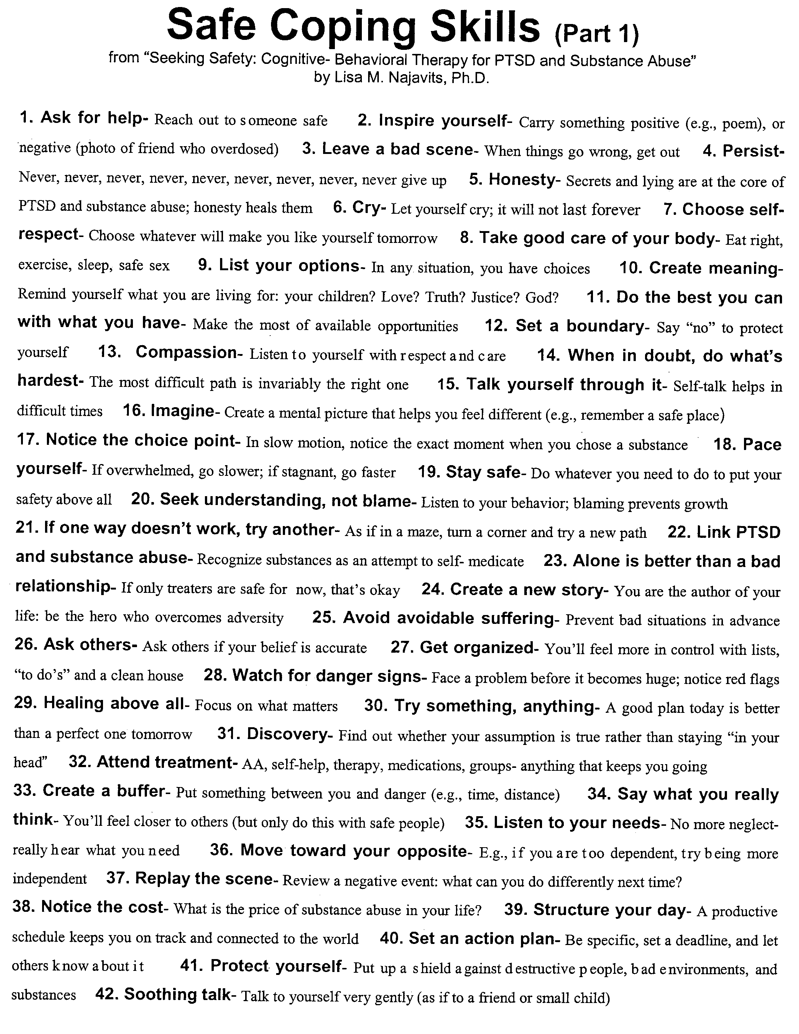

With appreciation to the Allies Program (Sacramento, CA) for formatting this Safe Coping List. © Guilford Press, New York. From: Najavits, L.M. Seeking Safety: A Treatment Manual for PTSD and Substance Abuse (2002). Only for personal use (with clients); for any other use contact <info@seekingsafety.org> or <permissions@guilford.com>
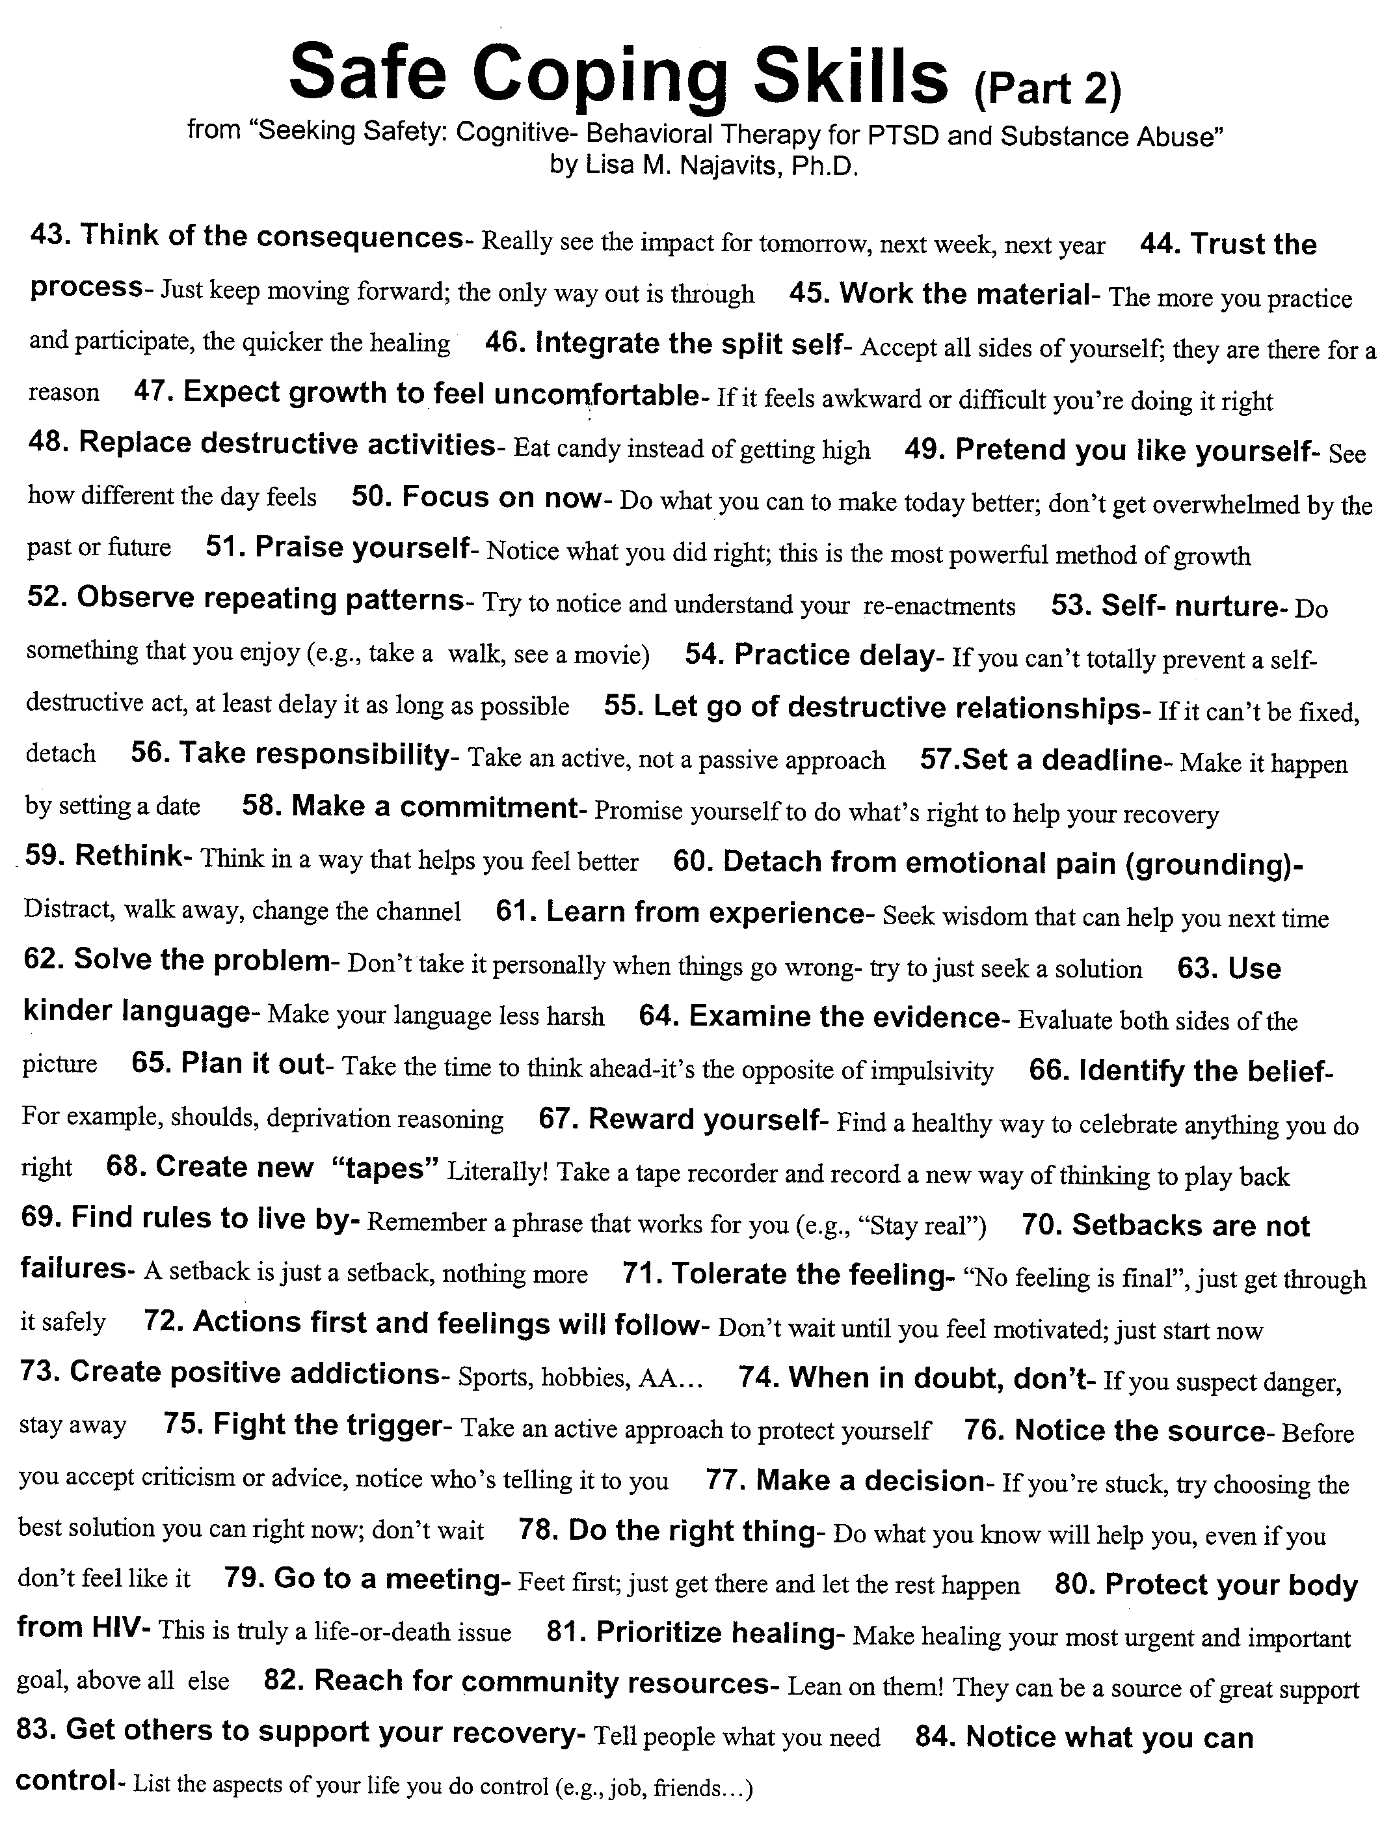
With appreciation to the Allies Program (Sacramento, CA) for formatting this Safe Coping List. © Guilford Press, New York. From: Najavits, L.M. Seeking Safety: A Treatment Manual for PTSD and Substance Abuse (2002). Only for personal use (with clients); for any other use contact <info@seekingsafety.org> or <permissions@guilford.com>

LEC/PCL-5 Administration and Scoring

1. Pages 1-2: "LEC" stands for Life Events Checklist, which can be used to identify a trauma to rate. Please see the DSM-5 for more information on what counts as a "trauma" per DSM-5.

2. The PCL-5 is a self-report measure that can be completed by patients in a waiting room prior to a session or by participants as part of a research study. It takes approximately 5-10 minutes to complete. Interpretation of the PCL-5 should be made by a clinician.

The PCL-5 can be scored in different ways:
- A total symptom severity score (rang - 0-80) can be obtained by summing the scores for each of the 20 items.
- DSM-5 symptom cluster severity scores can be obtained by summing the scores for the items within a given cluster, i.e., cluster B (items 1-5), cluster C (items 6-7), cluster D (items 8-14), and cluster E (items 15-20).
- A possible PTSD diagnosis can be made by treating each item rated as 2 = "Moderately" or higher as a symptom endorsed, then following the DSM05 diagnostic rule which requires at least: 1 B item (questions 1-5), 1 C item (questions 6-7), 2 D items (questions 8-14), 2 E items (questions 15-20).

For further information: www.ptsd.va.gov/professional/assessment/adult-sr/ptsd-checklist.asp

Trauma Symptom Checklist-40

How often have you experienced each of the following in the last month? Please circle one number, 0 through 3.
Never Often
1. Headaches 0 1 2 3__
2. Insomnia 0 1 2 3__
3. Weight loss (without dieting) 0 1 2 3__
4. Stomach problems 0 1 2 3__
5. Sexual problems 0 1 2 3__
6. Feeling isolated from others 0 1 2 3__
7. "Flashbacks"(sudden, vivid, distracting memories) 0 1 2 3__
8. Restless sleep 0 1 2 3__
9. Low sex drive 0 1 2 3__
10. Anxiety attacks 0 1 2 3__
11. Sexual overactivity 0 1 2 3__
12. Loneliness 0 1 2 3__
13. Nightmares 0 1 2 3__
14. "Spacing out" (going away in your mind) 0 1 2 3__
15. Sadness 0 1 2 3__
16. Dizziness 0 1 2 3__
17. Not feeling satisfied with your sex life 0 1 2 3__
18. Trouble controlling your temper 0 1 2 3__
19. Waking up early in the morning 0 1 2 3__
20. Uncontrollable crying 0 1 2 3__
21. Fear of men 0 1 2 3__
22. Not feeling rested in the morning 0 1 2 3__
23. Having sex that you didn't enjoy 0 1 2 3__
24. Trouble getting along with others 0 1 2 3__
25. Memory problems 0 1 2 3__
26. Desire to physically hurt yourself 0 1 2 3__
27. Fear of women 0 1 2 3__
28. Waking up in the middle of the night 0 1 2 3__
29. Bad thoughts or feelings during sex 0 1 2 3__
30. Passing out 0 1 2 3__
31. Feeling that things are "unreal" 0 1 2 3__
32. Unnecessary or over-frequent washing 0 1 2 3__
33. Feelings of inferiority 0 1 2 3__
34. Feeling tense all the time 0 1 2 3__
35. Being confused about your sexual feelings 0 1 2 3
36. Desire to physically hurt others 0 1 2 3__
37. Feelings of guilt 0 1 2 3__
38. Feeling that you are not always in your body 0 1 2 3__
39. Having trouble breathing 0 1 2 3__
40. Sexual feelings when you shouldn't have them 0 1 2 3__
Important note: this measure assesses trauma-related problems in several categories. According to John Briere, PhD “The TSC-40 is a research instrument only. Use of this scale is limited to professional researchers. It is not intended as, nor should it be used as, a self-test under any circumstances.” For a more current version of the measure, which can be used for clinical purposes (and for which there is a fee), consider the Trauma Symptom Inventory; contact Psychological Assessment Resources, 800-331-8378. The TSC-40 is freely available to researchers. No additional permission is required for use or reproduction of this measure, although the following citation is needed: Briere, J. N., & Runtz, M. G. (1989). The Trauma Symptom Checklist (TSC-33): Early data on a new scale. Journal of Interpersonal Violence, 4, 151-163. For further information on the measure, go to www.johnbriere.com.

ProQOL R-IV
PROFESSIONAL QUALITY OF LIFE SCALE
Compassion Satisfaction and Fatigue Subscales—Revision IV
Helping people puts you in direct contact with their lives. As you probably have experienced, your compassion for those you help has both positive and negative aspects. We would like to ask you questions about your experiences, both positive and negative, as a helper. Consider each of the following questions about you and your current situation. Select the number that honestly reflects how frequently you experienced these characteristics in the last 30 days.
0=Never | 1=Rarely | 2=A Few Times | 3=Somewhat Often | 4=Often | 5=Very Often

____ | 1. | I am happy.
____ | 2. | I am preoccupied with more than one person I help.
____ | 3. | I get satisfaction from being able to help people.
____ | 4. | I feel connected to others.
____ | 5. | I jump or am startled by unexpected sounds.
____ | 6. | I feel invigorated after working with those I help.
____ | 7. | I find it difficult to separate my personal life from my life as a helper.
____ | 8. | I am losing sleep over traumatic experiences of a person I help.
____ | 9. | I think that I might have been “infected” by the traumatic stress of those I help.
____ | 10. | I feel trapped by my work as a helper.
____ | 11. | Because of my helping, I have felt “on edge” about various things.
____ | 12. | I like my work as a helper.
____ | 13. | I feel depressed as a result of my work as a helper.
____ | 14. | I feel as though I am experiencing the trauma of someone I have helped .
____ | 15. | I have beliefs that sustain me.
____ | 16. | I am pleased with how I am able to keep up with helping techniques and protocols.
____ | 17. | I am the person I always wanted to be.
____ | 18. | My work makes me feel satisfied.
____ | 19. | Because of my work as a helper, I feel exhausted.
____ | 20. | I have happy thoughts and feelings about those I help and how I could help them.
____ | 21. | I feel overwhelmed by the amount of work or the size of my casework load I have to deal with.
____ | 22. | I believe I can make a difference through my work.
____ | 23. | I avoid certain activities or situations because they remind me of frightening experiences of the people I help.
____ | 24. | I am proud of what I can do to help.
____ | 25. | As a result of my helping , I have intrusive, frightening thoughts.
____ | 26. | I feel “bogged down” by the system.
____ | 27. | I have thoughts that I am a “success” as a helper.
____ | 28. | I can't recall important parts of my work with trauma victims.
____ | 29. | I am a very sensitive person.
____ | 30. | I am happy that I chose to do this work.
Copyright Information
© B. Hudnall Stamm, 1997-2005. Professional Quality of Life: Compassion Satisfaction and Fatigue Subscales, R-IV (ProQOL). http://www.isu.edu/~bhstamm. This test may be freely copied as long as (a) author is credited, (b) no changes are made other than those authorized below, and (c) it is not sold. You may substitute the appropriate target group for helper if that is not the best term. For example, if you are working with teachers, replace helper with teacher. Word changes may be made to any word in italicized square brackets to make the measure read more smoothly for a particular target group.
Disclaimer
This information is presented for educational purposes only. It is not a substitute for informed medical advice or training. Do not use this information to diagnose or treat a health problem without consulting a qualified health or mental health care provider. If you have concerns, contact your health care provider, mental health professional, or your community health center.

Self-scoring directions, if used as self-test
1. Be certain you respond to all items.
2. On some items the scores need to be reversed. Next to your response write the reverse of that score (i.e. 0=0, 1=5, 2=4, 3=3). Reverse the scores on these 5 items: 1, 4, 15, 17 and 29. Please note that the value 0 is not reversed, as its value is always null.
3. Mark the items for scoring:
a. Put an X by the 10 items that form the Compassion Satisfaction Scale: 3, 6, 12, 16, 18, 20, 22, 24, 27, 30.
b. Put a check by the 10 items on the Burnout Scale: 1, 4, 8, 10, 15, 17, 19, 21, 26, 29.
c. Circle the 10 items on the Trauma/Compassion Fatigue Scale: 2, 5, 7, 9, 11, 13, 14, 23, 25, 28.
4. Add the numbers you wrote next to the items for each set of items and compare with the average scores below.

Compassion Satisfaction Scale. The average score is 37 (SD 7; alpha scale reliability .87). About 25% of people score higher than 42 and about 25% of people score below 33. If you are in the higher range, you probably derive a good deal of professional satisfaction from your position. If your scores are below 33, you may either find problems with your job, or there may be some other reason—for example, you might derive your satisfaction from activities other than your job.
Burnout Scale. The average score on the burnout scale is 22 (SD 6.0; alpha scale reliability .72). About 25% of people score above 27 and about 25% of people score below 18. If your score is below 18, this probably reflects positive feelings about your ability to be effective in your work. If you score above 27 you may wish to think about what at work makes you feel like you are not effective in your position. Your score may reflect your mood; perhaps you were having a “bad day” or are in need of some time off. If the high score persists or if it is reflective of other worries, it may be a cause for concern.
Trauma/Compassion Fatigue Scale. The average score on this scale is 13 (SD 6; alpha scale reliability .80). About 25% of people score below 8 and about 25% of people score above 17. If your score is above 17, you may want to take some time to think about what at work may be frightening to you or if there is some other reason for the elevated score. While higher scores do not mean that you do have a problem, they are an indication that you may want to examine how you feel about your work and your work environment. You may wish to discuss this with your supervisor, a colleague, or a health care professional.

If you have any concerns, you should discuss them with a health care professional.

